**Deploying Flask web app using GCP**

*Assuming everyone knows how to push the code files to git hub.

**Basic structure of an app project:**

This guide uses the following structure for the flask-app project:

flask-app project structure:

**app.yaml:** Configure the settings of your App Engine application

**main.py:** Write the content of your application

**static:** Directory to store your static files

**style.css:** Basic stylesheet that formats the look and feel of your template files

**templates:** Directory for all of your HTML templates

**form.html:** HTML template to display your form

**submitted_form.html:** HTML template to display the content of a submitted form

**Model.pkl:** Trained model file which is saved in pickle format

**Requirements.txt:** Packages that you will need for your application to run

**Example github folder:**

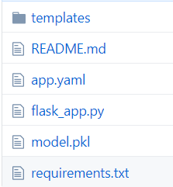

Note: Refer back to previous day lecture for templates, flask_app.py and requirements.txt files explanation.

**Creating the app.yaml file:**

You can configure your App Engine application's settings in the app.yaml file that you create manually or as part of the creation of your development project. The app.yaml file is a configuration file that tells App Engine how to run your application and how to map URLs to static files and Python modules.

To create the app.yaml file:

1. Create a file named app.yaml in the root directory of your project.
2. Add the following lines to the file:

entrypoint: "gunicorn -b :$PORT flask_app:app" #Replace flask_app with your file name

env: flex #environment options flexible or standard

runtime: python

runtime_config:

python_version: 3

Refer the link for more explanation:

<https://cloud.google.com/appengine/docs/standard/python/config/appref>

Once all the files are ready, push the files into github.

**Deployment using GCP:**

1. Connect to Google Cloud Platform console using <https://cloud.google.com/>
2. Create a project and give meaningful name for it because this will show up in the website link
3. Create a repository

To create a repository follow below steps:

From the top left under the **tools** select **Source Repositories**

Select **Add Repository** and choose Connect external repository

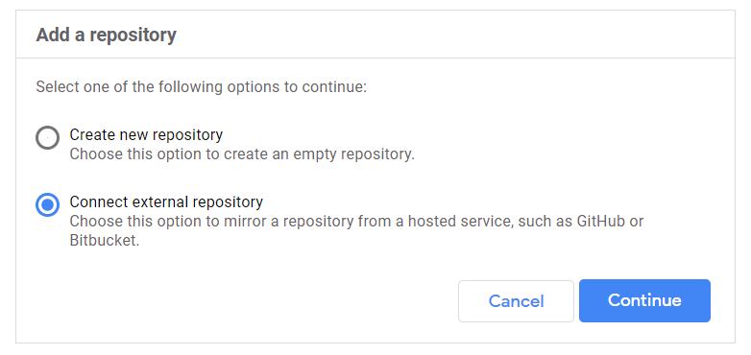

Click continue, In the next screen select your project in the drop down if not exist then create new project. And select Git provider as Github then click **Connect to GitHub.**

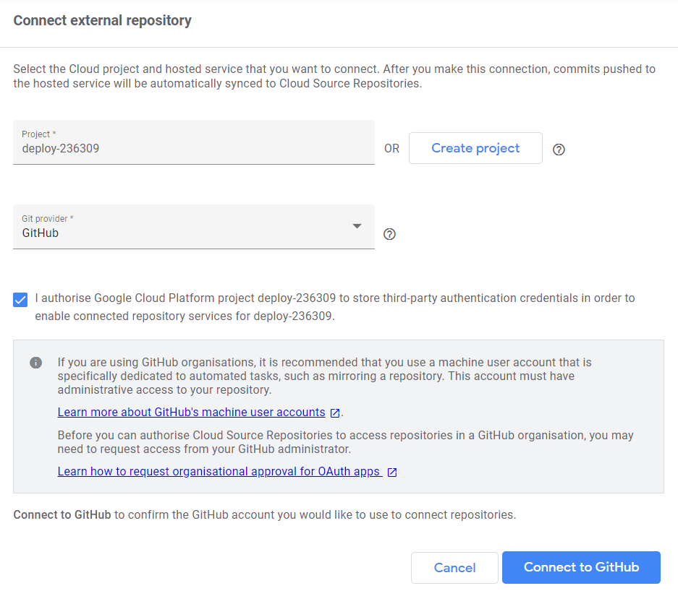

Choose the corresponding github repository where you have the flask app project files and click **connect selected repository**

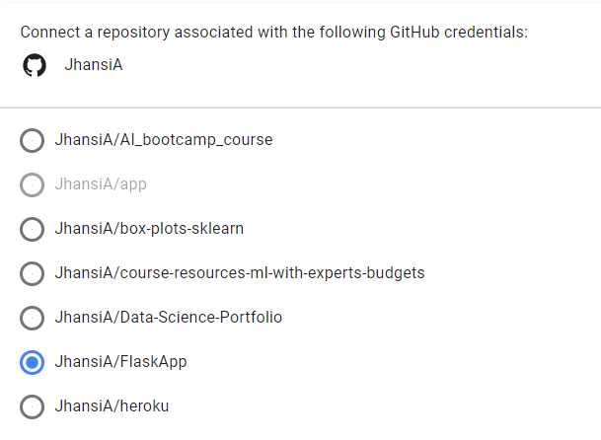

Once the connection successful, you can see the files of your git repository into GCP repository. Whenever you want to make the changes then you need to do push the changes to github and you can pull the changes using cloud shell into GCP.

1. Now press **Edit code** in the top right corner you will see something like below

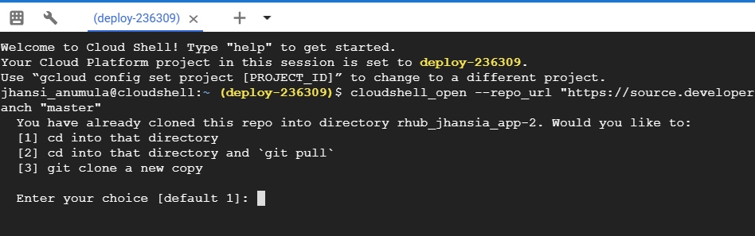

1. If there are no changes to pull from github then choose option 1 else option 2.
2. Now cloud shell is pointed to the repository folder

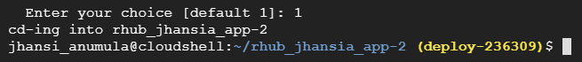

1. Now type **gcloud app deploy and enter** then it will ask for **Y/N** select Y if everything is fine. You can also mention the project while deploying using **gcloud app deploy --project[ID of project]**
2. Once deployment is done. To see the website link, type gcloud app browser and enter
3. You can use the website for further use. Usually website link will be in the below format

<https://[Project_ID].appspot.com/.> In my case it is <https://deploy-236309.appspot.com/.>

Note: If you face any errors during deployment you can refer log page or in the project dashboard page - > Error Reporting.